

Roll No.:
F22NDOCS1M01153
Subject:
Compiler Construction
Submitted To:
Mam Iffat Razzaq
Submitted By:
Sarmad Ali
Class:
7th-M-C
Department:
Computer Science
According to the requirements gives, the tasks will be:
- reg.txt
- lexer.py
- test.mini
- tokens.txt,symbol_table.txt
- semantic_analysis.txt, lexical_error.txt
- error handling and recovery = lexical_error.txt
- bonus = tokens_stats.txt
- comment removal = ir.txt = clean code
- CLI menu
- Flowchart
Task 1: Define Lexical Rules (Token Patterns)
The regular patterns of tokens in a table format are defines in file reg.txt as:
print(f"Regular expressions saved to {reg_file}")
Token Type | Regex / Pattern | Example
IDENTIFIER | [A-Za-z_][A-Za-z0-9_]* | counter, _var2
INTEGER_LITERAL | \d+ | 123
FLOAT_LITERAL | \d*\.\d+ | 3.14
CHAR_LITERAL | [^']' | 'a', 'Z'
STRING_LITERAL | "([^"\n]|(\\"))*" | "hello", "world"
OPERATOR | \+\+|--|\+=|-=|\*=|/=|==|!=|<=|>=|&&|\|\||[+\-*/%!=<>] | ++, --, =, +, -
SYMBOL | [\(\)\{\}\[\],;] | ;, (, {, }

We use lexer.py file and ply library of python for token identification as:
import ply.lex as lex
# Keywords
keywords = {
'int':'INT', 'float':'FLOAT', 'char':'CHAR',
'if':'IF', 'else':'ELSE', 'for':'FOR', 'while':'WHILE',
'return':'RETURN', 'break':'BREAK', 'continue':'CONTINUE'
}
# Token list
tokens = [
'IDENTIFIER', 'INTEGER_LITERAL', 'FLOAT_LITERAL',
'CHAR_LITERAL', 'STRING_LITERAL', 'OPERATOR', 'SYMBOL'
] + list(keywords.values())
# Ignored characters
t_ignore = ' \t'
# Operators and symbols
t_OPERATOR = r'\+\+|--|\+=|-=|\*=|/=|==|!=|<=|>=|&&|\|\||[+\-*/%!=<>]'
t_SYMBOL = r'[\(\)\{\}\[\],;]'
# Token definitions
def t_IDENTIFIER(t):
r'[A-Za-z_][A-Za-z0-9_]*'
t.type = keywords.get(t.value, 'IDENTIFIER') # Check for keywords
return t
def t_FLOAT_LITERAL(t):
r'\d*\.\d+'
return t
def t_INTEGER_LITERAL(t):
r'\d+'
return t
def t_CHAR_LITERAL(t):
r"'[^']'"
return t
def t_STRING_LITERAL(t):
r'"([^"\n]|(\\"))*"'
return t
# Comments
def t_COMMENT_SINGLELINE(t):
r'//.*' # Ignore single-line comments
pass
def t_COMMENT_MULTILINE(t):
r'/\*[\s\S]*?\*/'
t.lexer.lineno += t.value.count('\n') # Ignore multi-line comments
pass
# Unterminated string literal detection
def t_UNTERMINATED_STRING(t):
r'"[^"\n]*$'
print(f"Lexical Error (line {t.lineno}): Unterminated string literal")
t.lexer.skip(len(t.value))
# Unclosed multi-line comment detection
def t_UNCLOSED_COMMENT(t):
r'/\*[\s\S]*$'
print(f"Lexical Error (line {t.lineno}): Unclosed multi-line comment")
t.lexer.skip(len(t.value))

Task 2: Tokenizer Implementation:
We use re (regex) library of python to implement tokenizer as:
import re
# Define tokenize function to compile
def tokenize(code):
"""
Tokenize the input code.
Returns:
tokens_list: list of (type, value, line, column)
lexical_errors: list of lexical error messages
clean_code: input code with comments removed
"""
# Remove comments to generate clean source code
clean_code = re.sub(r"//.*", "", code) # single-line comments
clean_code = re.sub(r"/\*[\s\S]*?\*/", "", clean_code) # multi-line comments
lexer.input(clean_code)
tokens_list = []
lexical_errors = []
while True:
tok = lexer.token()
if not tok:
break
col = find_column(tok.lexpos, clean_code)
tokens_list.append((tok.type, tok.value, tok.lineno, col))
# Redefine t_error temporarily to collect errors instead of printing
def t_error_collect(t):
lexical_errors.append(
f"Lexical Error (line {t.lineno}, col {find_column(t.lexpos, clean_code)}): Illegal character '{t.value[0]}'"
)
t.lexer.skip(1)
lexer.errorfunc = t_error_collect # override default error function
return tokens_list, lexical_errors, clean_code
It reads test.mini file to recognize all tokens. For line and columns numbers and to detect errors, we use ply library as:
# Track line numbers
def t_newline(t):
r'\n+'
t.lexer.lineno += len(t.value)
# Error handling
def t_error(t):
print(f"Lexical Error (line {t.lineno}): Illegal character '{t.value[0]}'")
t.lexer.skip(1)
# Helper function for column to calculate token position in the code
def find_column(lexpos, code):
last_cr = code.rfind('\n', 0, lexpos)
if last_cr < 0:
last_cr = -1
return lexpos - last_cr
And the error if occur or not are save in lexical_error.txt file as:
print(f"Lexical errors saved to {lexical_errors_file}")

Task 3: Symbol table construction
We use SemanticAnalyzer class and define symbol table in semantic_analyzer.py.
class SemanticAnalyzer:
def write_symbol_table(self, filename="symbol_table.txt"):
"""
Write the symbol table to a file in a readable format.
"""
with open(filename, "w") as f:
f.write("Name\tType\tValue\tDeclaredAt\n")
for name, info in self.symbols.items():
f.write(f"{name}\t{info['type']}\t{info.get('value', '-')}\t{info.get('declared_at', '-')}\n")
Then, we use it in compiler.py to create and update the symbol table.
symbol_table = {}
with open(tokens_file, 'w') as tf:
for tok_type, tok_value, tok_line, tok_col in tokens_list:
tf.write(f"<{tok_line}, {tok_col}> <{tok_type}, {tok_value}>\n")
# Update symbol table for identifiers/literals
if tok_type in ['IDENTIFIER','INTEGER_LITERAL','FLOAT_LITERAL','CHAR_LITERAL','STRING_LITERAL']:
if tok_value not in symbol_table:
category = 'variable' if tok_type == 'IDENTIFIER' else 'literal'
symbol_table[tok_value] = {
'type': tok_type.lower().replace('_literal',''),
'category': category,
'value': tok_value if category == 'literal' else '—',
'line': tok_line,
'column': tok_col
}
And the output is shown in symbol_table.txt file using:
print(f"Symbol table saved to {symbol_table_file}")

Task 4: Token Stream File Creation
The tokens are saved in tokens.txt file as:
with open(tokens_file, 'w') as tf:
for tok_type, tok_value, tok_line, tok_col in tokens_list:
tf.write(f"<{tok_line}, {tok_col}> <{tok_type}, {tok_value}>\n")
# Update symbol table for identifiers/literals
if tok_type in ['IDENTIFIER','INTEGER_LITERAL','FLOAT_LITERAL','CHAR_LITERAL','STRING_LITERAL']:
if tok_value not in symbol_table:
category = 'variable' if tok_type == 'IDENTIFIER' else 'literal'
symbol_table[tok_value] = {
'type': tok_type.lower().replace('_literal',''),
'category': category,
'value': tok_value if category == 'literal' else '—',
'line': tok_line,
'column': tok_col
}
print(f"Tokens saved to {tokens_file}")
Task 5: Error Reporting and Recovery
The lexical error is define in lexer,py as:
# Error handling
def t_error(t):
print(f"Lexical Error (line {t.lineno}): Illegal character '{t.value[0]}'")
t.lexer.skip(1)
def t_UNTERMINATED_STRING(t):
r'"[^"\n]*$'
print(f"Lexical Error (line {t.lineno}): Unterminated string literal")
# Redefine t_error temporarily to collect errors instead of printing
def t_error_collect(t):
lexical_errors.append(
f"Lexical Error (line {t.lineno}, col {find_column(t.lexpos, clean_code)}): Illegal character '{t.value[0]}'"
)
t.lexer.skip(1)
lexer.errorfunc = t_error_collect # override default error function
return tokens_list, lexical_errors, clean_code
# Save lexical errors
with open(lexical_errors_file, "w") as f:
if lexical_errors:
f.write("Lexical Errors:\n")
for err in lexical_errors:
f.write(err + "\n")
else:
f.write("No lexical errors detected.\n")

This code detects and save error in lexical_error.txt file and also handle error while writing clean code. The file is saved as:
print(f"Semantic analysis saved to {semantic_file}")
If error is not found, it show no error. If error is found, it shows that error.
Bonus:
1. Token Counting
Token statistics are saved as:
# Count tokens by type
counts = Counter(tok_type for tok_type, _, _, _ in tokens_list)

# Prepare table formatting
header_token = "Token Type"
header_count = "Count"
line_width = 30 # adjust for neatness
# write token stats to file
with open(token_stats_file, "w") as f:
f.write("+" + "-" * (line_width - 1) + "+\n")
f.write(f"| {header_token.ljust(20)} | {header_count.rjust(5)} |\n")
f.write("+" + "-" * (line_width - 1) + "+\n")
for token_type, count in counts.items():
f.write(f"| {token_type.ljust(20)} | {str(count).rjust(5)} |\n")
f.write("+" + "-" * (line_width - 1) + "+\n")

print(f"Token statistics saved to {token_stats_file}")
After this the token_stats.txt file is created with table format as:
+-----------------------------+
| Token Type | Count |
+-----------------------------+
| INT | 4 |
| IDENTIFIER | 8 |
| SYMBOL | 13 |
| OPERATOR | 5 |
| INTEGER_LITERAL | 4 |
| IF | 1 |
| RETURN | 1 |
+-----------------------------+
2. A GUI or CLI menu to choose options like:
- View tokens
- View symbol table
- View cleaned source
These tasks are performed in cli.py file using os library of python as:
import os

def show_file(filename, title):
"""Helper to display file contents nicely."""
print("\n" + "="*50)
print(f" {title}")
print("="*50)
if os.path.exists(filename):
with open(filename, "r") as f:
content = f.read().strip()
print(content if content else "[Empty File]")
else:
print("[File not found!]")
print("="*50 + "\n")

def cli_menu():
"""Interactive command-line interface."""
while True:
print("\nMiniLang Lexical Analyzer Menu")
print("---------------------------------")
print("1. View Tokens")
print("2. View Symbol Table")
print("3. View Token Statistics")
print("4. View Cleaned Source Code")
print("5. View Lexical Errors")
print("6. View Semantic Analysis Report")
print("0. Exit")

choice = input("Enter your choice: ")

if choice == '1':
show_file("tokens.txt", "TOKEN STREAM")
elif choice == '2':
show_file("symbol_table.txt", "SYMBOL TABLE")
elif choice == '3':
show_file("token_stats.txt", "TOKEN STATISTICS")
elif choice == '4':
show_file("clean_source.mini", "CLEANED SOURCE CODE")
elif choice == '5':
show_file("lexical_errors.txt", "LEXICAL ERRORS")
elif choice == '6':
show_file("semantic_analysis.txt", "SEMANTIC ANALYSIS")
elif choice == '0':
print("Exiting MiniLang Analyzer. ✅")
break
else:
print("Invalid choice. Please try again.")

# Call CLI menu at the end
if __name__ == "__main__":
cli_menu()

3. Screenshot of execution and error detection
The execution is done in the dedicated terminal with outputs stated above. It shows output of each file as:
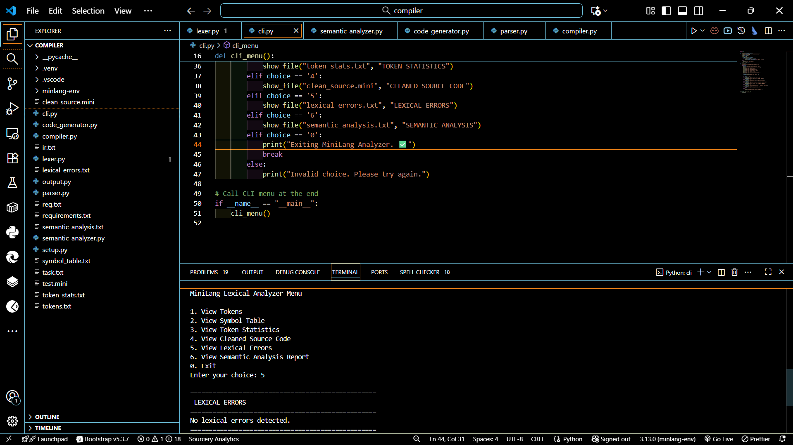
4. Flowchart
The flowchart of the whole process is given as:
Take test.mini
Start

Read Source File

If logical or syntax error
Parsing using parser.py
Save tokens info in tokens.txt
Print error in lexical_error.txt
Tokens Matched?
Match Tokens with regex pattern
Take Tokens
Convert into Tokens

Print error in semantic_analyzer.txt

Take tokens after semantic analyzing

Generate IR using code_generator.py

Stop/End
Backend
Clean Code in clean_source.mini
Intermediate Representation in ir.txt

